**Family and Medical Leave**

The federal Family Medical Leave Act (FMLA) of 1993, as amended in 2008, requires employers with 50 or more employees to provide eligible employees with unpaid leave. There are two types of leave available, including the basic 12-week entitlement (**Basic FMLA Leave**) and military family (**Military Family Leave**) entitlements described in this policy. This policy provides a general summary of the FMLA. In addition, a copy of the United States Department of Labor Form WHD 1420, which includes information regarding the FMLA, is attached to this policy.

**Eligibility For FMLA:**

Employees are eligible for FMLA leave if they:

* Worked for the company for at least 12 months (which does not need to be continuous if there is not a 7-year break in service);
* Have worked at least 1,250 hours for the company during the 12 calendar months immediately preceding the request for leave; and
* Are employed at a worksite that has 50 or more employees within a 75 mile radius.

Under the FMLA, therefore, some [***Employee] employees will be eligible for FMLA leave and others will not. For those employees who are not eligible for FMLA leave, the Company has a separate policy set forth below entitled “Leave of Absence for Employees Not FMLA Eligible.”

**Requesting Use of FMLA:**

If an employee’s need for FMLA leave is foreseeable (including medical or other appointments that are scheduled in advance), the employee must give the Company at least 30 days’ prior notice. If this is not practicable, employees must at least give notice as soon as practicable (generally within two (2) business days of learning of the need for leave). Failure to provide such notice may be grounds for delay of leave.

If an employee’s need for FMLA leave is not foreseeable, the employee must call his or her supervisor at least 30 minutes prior to the start of his or her shift unless there is an emergency that makes it impossible for the employee to call at that time. Failure to do so will result in FMLA leave being denied, the employee will be given an unexcused absence under the Company’s attendance and punctuality policy, and the employee may not use paid time off benefits to cover this absence.

Employees should contact Human Resources to request a family and medical leave or with any questions about FMLA.

Employees must provide sufficient information for the Company to determine if the leave may qualify for FMLA protection and the anticipated timing and duration of the leave. Sufficient information may include that the employee is unable to perform job functions, the family member is unable to perform daily activities, the need for hospitalization or continuing treatment by a health care provider, or circumstances supporting the need for military family leave. Calling in “sick” or “ill” without further explanation as to the specific medical condition or reason for leave is not sufficient.

Employees also must inform the Company if the requested leave is for a reason for which FMLA leave was previously taken or certified. This means the employee must specifically mention the FMLA and the specific medical condition or reason why FMLA leave is needed.

**Basic FMLA Leave**

Employees who meet the eligibility requirements described above are eligible to take up to 12 weeks of leave during a rolling 12-month period (measured backwards from each day FMLA leave is used) for one, or more, of the reasons described below.

1. To care for the employee’s son or daughter during the first 12 months following the birth;

2. To care for a child during the first 12 months following placement with the employee for adoption or foster care;

3. To care for a spouse, authorized domestic partner, son, daughter or parent (called a “covered relation”) with a serious health condition;

4. For incapacity due to pregnancy, prenatal medical care of child birth; or

5. Because of the employee’s own serious health condition that makes the employee unable to perform one or more of the essential functions of his or her job.

In cases where a couple is both employed by the Company, the two spouses together may take a combined total of 12 weeks’ leave during the 12-month period for reasons 1 and 2, or to care for a parent pursuant to reason 3.

**Military Family Leave**

There are two types of Military Family leave available.

1. **Qualifying Exigency Leave**. Employees meeting the eligibility requirements described above may be entitled to use up to 12 weeks of their Basic FMLA Leave entitlement to address certain qualifying exigencies. Leave may be used if the employee’s spouse, son, daughter, or parent is on covered active duty or called to covered active duty status in the regular or reserve components of the Armed Forces. Qualifying exigencies may include:

* *Short-notice deployment*: Leave (up to 7 calendar days) to address any issue that arises from an impending call or order to covered active duty in support of a contingency operation seven days or less prior to the date of deployment.
* *Military events and related activities*: Leave to attend any military ceremony, program, or event related to the covered active duty or call to covered active duty status or to attend certain family support or assistance programs and informational briefings.
* *Child and school activities*: Leave to arrange or provide for childcare or school-related activities.
* *Financial and legal arrangements*: Leave to make or update various financial or legal arrangements.
* *Counseling*: Leave to attend non-medical counseling (by someone other than a health care provider) when necessary as a result of the covered active duty or call to covered active duty status.
* *Rest and recuperation*: Leave to spend time with a covered military member who is on short-term, temporary, rest and recuperation leave during the period of deployment (up to five days).
* *Post-deployment activities*: Leave to attend arrival ceremonies (including funeral or memorial services), reintegration briefings and events, and any other official ceremony or program sponsored by the military for a period of 90 days following the termination of the covered military member’s covered active duty status.
* *Additional activities*: Leave to address other events arising from military duty agreed upon between the Human Resources Manager and the employee.

2) **Leave to Care for Covered Servicemember**. Employees who meet the eligibility requirements for FMLA leave may take up to 26 weeks of leave in a single rolling forward 12-month period to care for a covered servicemember who has a serious injury or illness incurred in the line of duty on covered active duty. During that 12-month period, any Basic FMLA leave that is used also counts against the 26-week entitlement (i.e., the maximum amount of leave is 26 weeks-not 38 weeks).

**Certification:**

Employees requesting leave because of their own, covered relation's or covered servicemember’s serious health condition must be supported by a certification by the health care provider of the employee or employee’s family/military member. Certification for a qualifying exigency must also be provided along with a copy of the covered military member’s covered active duty orders or other documentation issued by the military which indicates that the covered military member is on covered active duty or call to covered active duty status in support of a contingency operation, and the dates of covered military member’s covered active duty services.

Certification Forms may be obtained from Human Resources. When a leave is requested, the Company will notify the employee of the requirement for certification and when it is due (at least fifteen (15) days from date of request). Employees must provide a complete and sufficient certification if required. Failure to provide adequate certification may result in the denial of leave.

The Human Resources Director may contact the health care provider completing a medical certification in an effort to authenticate the certification or obtain additional clarification required to understand the meaning or handwriting on the certification.

If leave is taken because of an employee’s own serious health condition or to care for a covered relation, the Company, at its expense, may require an examination by a second health care provider designated by the Company, if it reasonably doubts the medical certification initially provided. If the second health care provider's opinion conflicts with the original medical certification, the Company, at its expense, may require a third, mutually agreeable, health care provider to conduct an examination and provide a final and binding opinion.

**Recertification:**

The Company will require recertification of a medical condition for employee’s own serious health condition or to care for a covered relation every six months in connection with an absence. Recertification may be requested more often under some circumstances such as with an extension of leave or if circumstances described in the previous certification have changed significantly, the Company has information that casts reasonable doubt on the need for leave, or the employee requests an extension to the leave.

**Reporting While on Leave:**

If continuous or reduced schedule leave is taken because of an employee’s own serious health condition or to care for a covered relation, employees must report periodically on their status and intent to return to work. In addition, employees must give notice as soon as practicable (within two (2) business days if feasible) if the dates of leave change or are extended or initially were unknown.

**Substituting Paid Leave for Unpaid Leave:**

FMLA leave is unpaid. You may choose to substitute vacation time that you have accrued through Store Supply Warehouse LLC.

When an employee is absent due to a work-related illness or injury that meets the definition of a serious health condition, the absence will be counted against the employee’s entitlement under this policy. In other words, the employee is using FMLA leave concurrently with the workers’ compensation absence. An employee is not required to substitute paid time off for an absence covered under workers’ compensation.

Although FMLA unpaid leave, you may be eligible for short or long-term disability payments and/or workers' compensation benefits under those insurance plans or policies.

**Benefits and Protections:**

During an approved family and medical leave, the Company will maintain health benefits as if the employee continued to be actively employed. If paid leave is substituted for unpaid family/medical leave, the Company will deduct the employee’s portion of the health plan premium as a regular payroll deduction. If the leave is unpaid, the employee must pay his/her portion of the premium. Health care coverage will cease if premium payment is more than thirty (30) days late. If payment is more than fifteen (15) days late, a letter will be sent to this effect. If payment is not received within fifteen (15) days after the date of this letter, health care coverage may cease.

Regardless of whether or not an employee returns to work following FMLA leave, the Company may recover the employee’s share of premiums that were paid by the Company. If an employee fails to return to work for at least thirty (30) calendar days at the end of the leave period, he or she may also be required to reimburse the Company for the Company’s share of the health benefit premiums paid by the Company for maintaining coverage during the leave, unless the employee cannot return to work because of a serious health condition or other circumstances beyond his or her control.

On return from an approved family and medical leave most employees will be returned to their same position held when leave commenced, or to an equivalent position with equivalent benefits, pay and other terms and conditions of employment.

Use of an approved family and medical leave will not result in the loss of any employment benefit that accrued prior to the start of an employee’s leave.

**Intermittent and Reduced Schedule Leave:**

Leave because of a serious health condition or serious injury or illness may be taken intermittently (in separate blocks of time due to a single health condition) or on a reduced leave schedule (reducing the usual number of hours worked per workweek or workday) if medically necessary. Leave due to qualifying exigencies may also be taken on an intermittent basis. If leave is unpaid, the Company will reduce an employee’s salary based on the amount of time actually worked.

Employees who require intermittent leave or reduced leave schedule must arrange medical treatments and appointments to minimize work disruption.

An employee requesting non-continuous leave that is foreseeable and for planned medical treatment may be required to transfer temporarily to an available alternative position offered by the Company for which the employee is qualified and which better accommodates recurring periods of leave than the regular employment position of the employee. The employee will be entitled to equivalent pay and benefits, but will not necessarily be assigned the same duties in the alternative position.

**Returning From Leave:**

If leave is taken because of an employee’s own serious health condition (except when employee is taking intermittent leave), employees are required to provide medical certification that they are fit to resume work. Fitness for Duty Certification Forms may be obtained from Human Resources. Employees failing to provide the Fitness for Duty Certification Form will not be permitted to resume work until it is provided and may no longer be entitled to reinstatement.

**State and Local Family and Medical Leave Laws:**

Where state or local family and medical leave laws offer more protections or benefits to employees, the protections or benefits provided by such laws will apply.

**No Work While on Leave:**

While on approved leave, it is expected that employees only engage in those activities that are consistent with the reason for the leave. Working another job or engaging in self-employment while on an approved leave of absence is grounds for immediate termination, to the extent permitted by law.

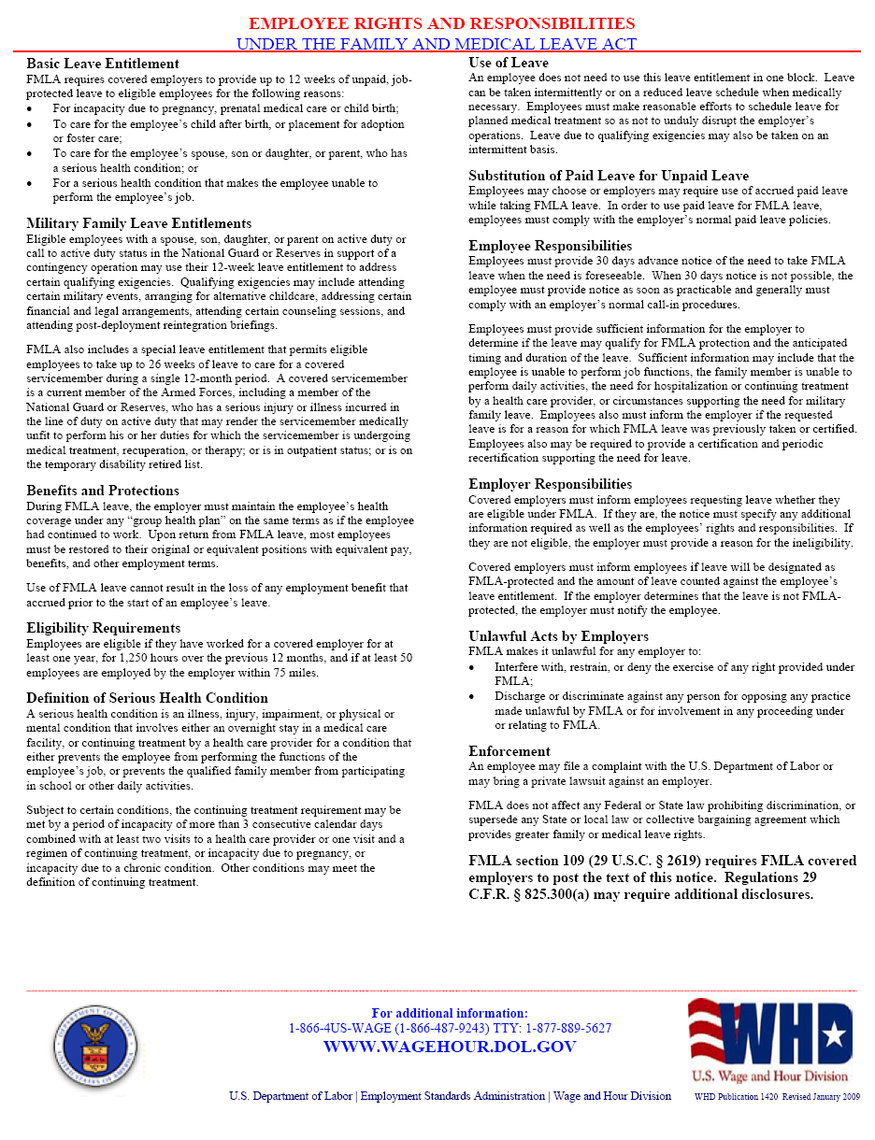

**Leave of Absence for Employees Not FMLA Eligible**

A leave of absence without pay not in excess of six (6) weeks within a rolling twelve-month period due to proven sickness, illness or pregnancy that justifies the absence may, at the Company’s sole discretion, and taking into consideration business needs, be granted to full-time employees.

A granted leave of absence may, at the Company’s sole discretion and taking into consideration business needs, be extended to a maximum of up to three (3) months based on a doctor’s certification stating that the employee is unable to return to work at the conclusion of the initial leave period. The Company reserves the right to have the employee examined by a doctor that the Company selects prior to granting an extension of the leave and prior to the employee returning to work.

A leave of absence without pay for reason other than illness, injury, or pregnancy may be granted, at the Company’s sole discretion and taking into consideration business needs, to a full-time employee. Such granted leave of absence shall not be in excess of fifteen (15) days, but may be extended at the sole discretion of the Company and taking into consideration business needs. A leave of absence may not be taken for illnesses of less than ten (10) working days duration.

For all non-medical leaves of absence, the employee must submit a written request stating the specific reason for and the length of the desired leave to the immediate supervisor in advance of the requested effective date of the leave. All leaves of absence will be considered by the Company, and if authorized, the Employee will be provided a written notification.

During any leave of absence, an employee may continue to participate in the Company’s insurance plan, to the extent allowed by the Plan Document. If continuation of insurance is desired, the employee must pay their normal monthly contribution of the insurance coverage cost for the duration of the leave of absence. The necessary payment must be made to the Company prior to the end of each month during the leave of absence. Failure to pay the required costs will result in cancellation of the employee’s participation in said plan. Reinstatement to the plan upon returning to work may have serious restrictions depending on specific conditions or terms of the plan. Employees on any leave of absence will not receive paid holidays or accrue any vacation pay. Time spent on a leave of absence will not be considered as time worked for any purpose.

An employee who fails to return to work at the end of their established leave or who fails to properly request an extension in writing prior to the expiration of the leave shall be deemed to have voluntarily resigned from the Company’s employment.

At least one (1) week prior notification of intention to return from leave of absence for sickness, illness or pregnancy must be given to the Company. A reasonable effort will be made to hold open the employee’s position during the leave of absence. In the event the Company hires a replacement for an employee on a leave of absence, the Company will attempt to locate a similar position for the employee returning from leave of absence. However, the Company does not guarantee reinstatement to any position within the Company upon expiration of a non-FMLA leave of absence.

The Company or its designee has the right to verify and validate the reason the employee has given to obtain a non-FMLA leave of absence. Falsification of the reason for leave of absence or extension thereof will result in discipline up to and including discharge.